Valve Coating Machine

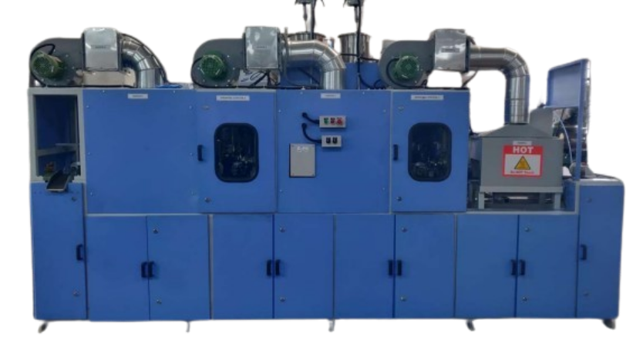

- Product Parameters:

Electrical Power Supply | 415V AC, 50Hz, 6Kw
Pneumatic Air Supply | 4-6 bar
Pressure feed auto gun | 1 (Iwata Make)
Pressure feed tank with electric stirrer | 9 Liters
Cubic Feet per Minute (CFM) | 10

